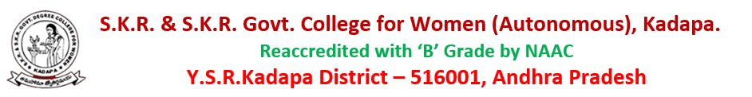DEPARTMENT OF MICROBIOLOGY
Individual Time-Table-2021-2022 (II Sem and IV Sem)

NAME : Dr. B.PRIYADARSINI
LECTURER IN MICROBIOLOGY

Day | 1 | 2 | 3 | 4 | 5 | 6
Mon |  |  | II BMC | II BMC | II BMC
Tue | I BMC |  | II BMC
Wed | II BMC | II BMC |  | II BMC | I BMC | II BMC
Thu | I BMC | I BMC |  |  | II BMC
Fri |  | IBMC |  | II BMC |  | II BMC
Sat |  | II BMC |  | I BMC

Work load:
No of theory hours = 12
No of practical hours = 06
Total no of hours = 18

